|  |
| --- |
| Software Engineering  Software Architecture  Gruppe Blau  **CS1_Task 09 und Task 10** |

Inhaltsverzeichnis

1 Software Architecture 3

1.1 Block Diagram 3

1.2 Layers Architecture Pattern 3

1.3 Package Diagram 3

1.4 Component Diagram 4

1.5 Deployment Diagram 4

# Software Architecture Task 09

## Block Diagram

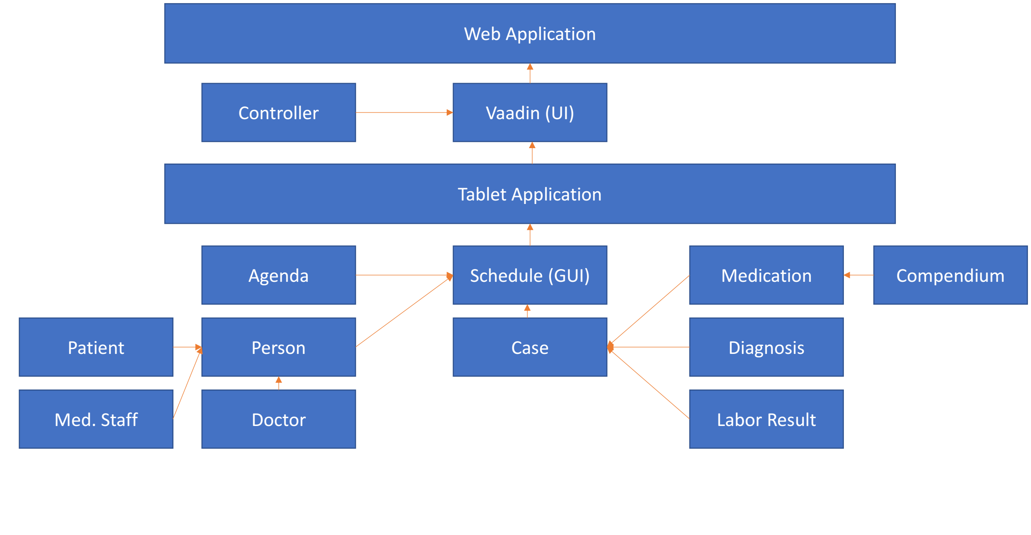

## Layers Architecture Pattern

## Package Diagram

## Component Diagram

## Deployment Diagram